[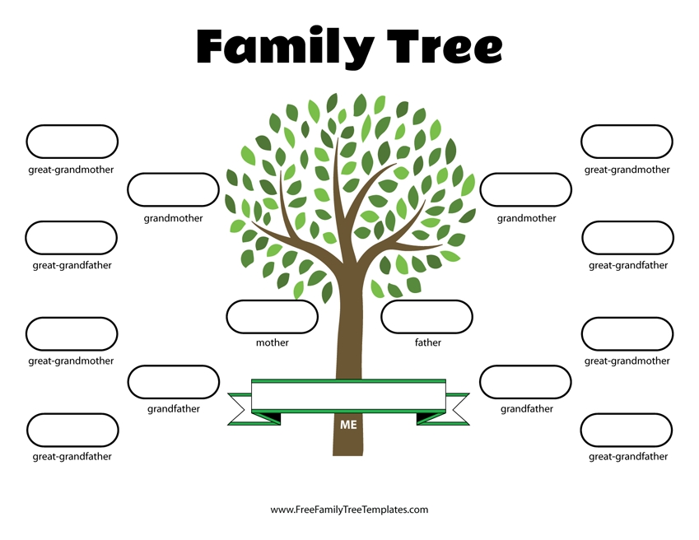](http://iranea.org/printable-blank-family-tree-template/family-tree-lesson-plans-large-tree-templates-for-designing/)