HOME LEARNING ACTIVITIES
Theme: Summer Week: 2nd June

Colour each block when you complete the Learning Activity
Maths  Make a clock from sticks/stones in the garden and ask someone to call out a time  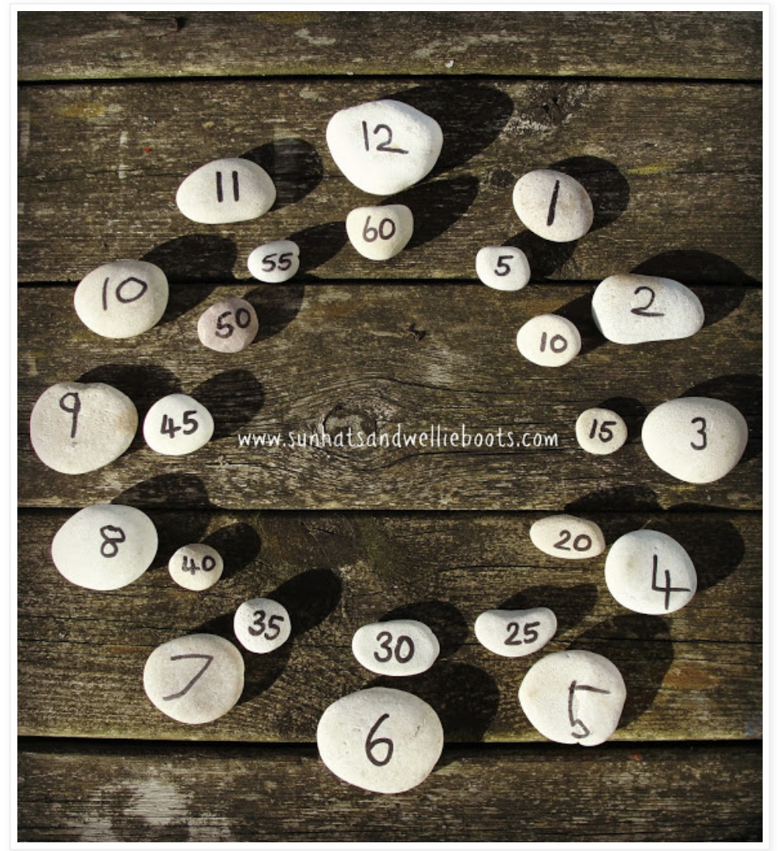 | Cookery  Make a Summer Fruit Smoothie similar to the recipe in your work pack | Art  Gather twigs, flowers or stones from your garden to make a life sized you!  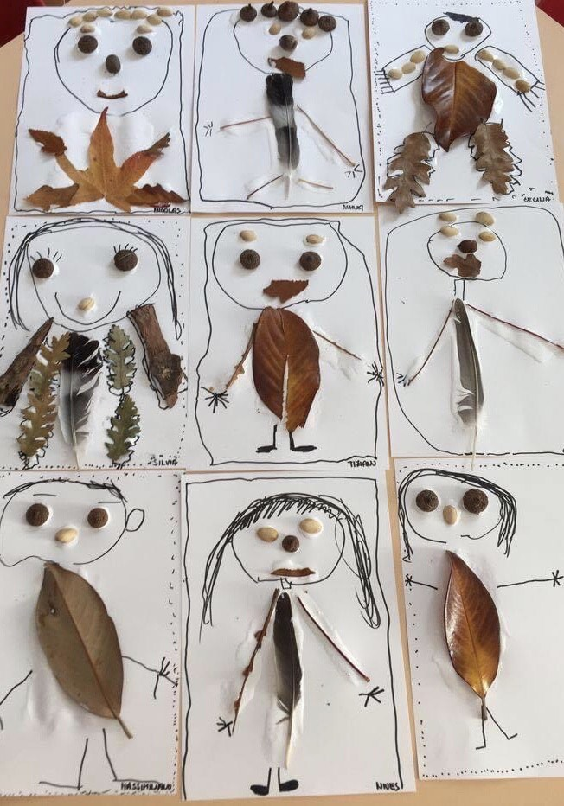
PE  Take part in 30mins exercise each daily- Run, Walk, Cycle, Gymnastics…Your choice! | DEAR Time  Drop everything you are doing and read a book for 20minutes | Spellings  Practice your spelling words by writing them with chalk on the ground
Science  Go on a hunt for plants and flowers in your local area. Use the scavenger sheet provided in work pack | Outdoors  Take part in Kids outdoor challenge posted on School Website | English  Write a poem about Summer using your five senses
Keep a diary
In your diary, write about two things you did each week: Think about what you did, how you did it, who helped you, where you where and when it took place

