Home Learning Activities
COLOUR EACH BLOCK WHEN YOU COMPLETE THE LEARNING ACTIVITIY
Theme: Communicating and Keeping in Touch
Oral language/ SPHE  Play Guess the object with your family  (See Instructions below) | Life Skills/ SPHE  Phone/ video call one new person you miss each day. |  |  |  |  |  |  | English  Write a letter/ email/ postcard or send a card to someone.  (You can reply to your letter from me if you like)
 | M |  | T | W | Th | F
SESE/ Physical Education  Play blind directions with your family.  (See below for details) | Social Skills/ Oral Language/ SESE  Create your family tree with your family.  (Template below) |  |  |  |  |  |  | Cookery  Fruit Salad  (Recipe sent separate)
Art  Draw and colour a picture of the people you miss the most at the minute. | Physical Education  Take part in 30-minutes of exercise each day. |  |  |  |  |  |  | English  My Personal Journal  Complete 1 entry about your week in your personal journal.
 | M | T |  | W | Th |  | F
Home learning Activities
Here are some activities that will be completed weekly as part of the Middle 1 Home Learning Activities:
My Personal Journal
This unique time will be spoken about in history and I would like Middle 1 to record their time to create something they can treasure for years. This will allow pupils to reflect on their time at home and to share thoughts and feelings. My Personal Journal can include pictures or writing based on your child’s abilities. (More detail in individual email.) 1 or 2 entries per week is plenty and the children will be able to present these when they return to school.
Physical Activity
Physical Activity is very important at this time to help support health and wellbeing. The HSE recommends that all children and young people aged between 2 and 18 years should be active for at least 60 minutes per day. Ideas to help achieve this are:
- The Body Coach Joe Wicks provides a 30-minute workout each day at 9am. This can be watched at any time of the day. www.youtube.com/thebodycoachtv
- Movement and mindfulness videos www.gonoodle.com
- Daily 10 minute exercise videos https://rtejr.rte.ie/10at10/
- Cosmic Kids Yoga (yoga and mindfulness) https://www.youtube.com/user/CosmicKidsYoga

Playing football, racing or daily walks are all great exercise and fun!

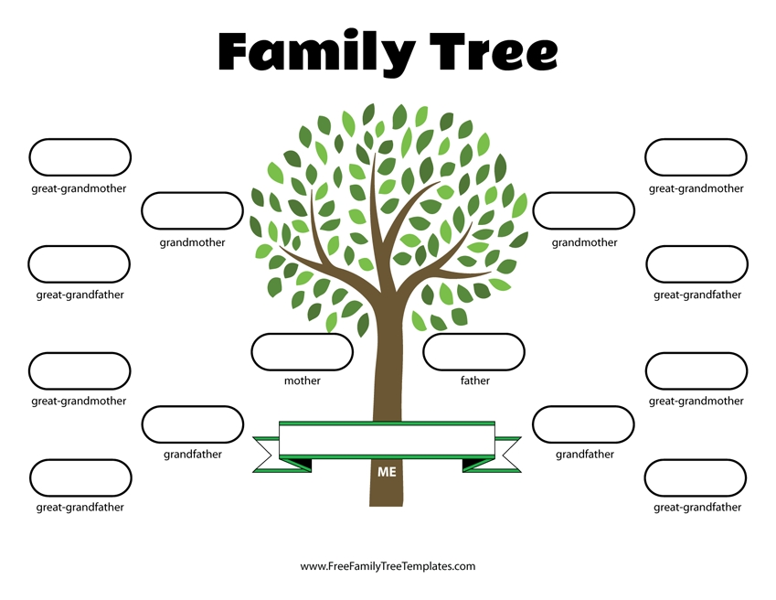Guess the Object
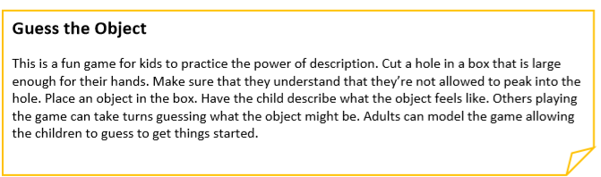
Cookery: Fruit Salad (Instructions sent separately)
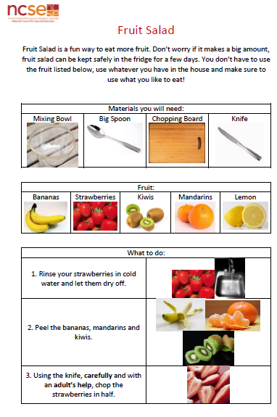
Blind Directions Game
*Make sure you have an adult present and keep the game sensible and safe.
Create a simple path or obstacle course in the garden. Blindfold one person and give them directions to get from the start of the course/ path to the end. Make sure your instructions and directions are clear and also make sure you are listening carefully. Take turns to complete this.

