Home Learning Activities
COLOUR EACH BLOCK WHEN YOU COMPLETE THE LEARNING ACTIVITIY
Go on a short walk and point out 5 signs of Spring. | Complete 1 Job around the house each day this week. | Play outside for 30 Minutes.
Create a birds feeder  (See pictures below) | Play a board game with your family. | Think about your favourite place to visit, draw a picture/ print a picture and write one sentence about it.
Read a short story with a family member. | Take part in a 30-minute exercise routine each day.  (E.g. The body coach on You Tube/ go noodle) | My Personal Journal  Complete 1 entry about your week in your personal journal.
See below for more detail
Home learning Activities
Here are some activities that will be completed weekly as part of the Middle 1 Home Learning Activities:
My Personal Journal
This unique time will be spoken about in history and I would like Middle 1 to record their time to create something they can treasure for years. This will allow pupils to reflect on their time at home and to share thoughts and feelings. My Personal Journal can include pictures or writing based on your child’s abilities. (More detail in individual email.) 1 or 2 entries per week is plenty and the children will be able to present these when they return to school.
Physical Activity
Physical Activity is very important at this time to help support health and wellbeing. The HSE recommends that all children and young people aged between 2 and 18 years should be active for at least 60 minutes per day. Ideas to help achieve this are:
- The Body Coach Joe Wicks provides a 30-minute workout each day at 9am. This can be watched at any time of the day. www.youtube.com/thebodycoachtv
- Movement and mindfulness videos www.gonoodle.com
- Daily 10 minute exercise videos https://rtejr.rte.ie/10at10/
- Cosmic Kids Yoga (yoga and mindfulness) https://www.youtube.com/user/CosmicKidsYoga

Arts and Crafts
Each week a new idea for arts and crafts will be included. I will add photos/ ideas /instructions to help with the art craft.
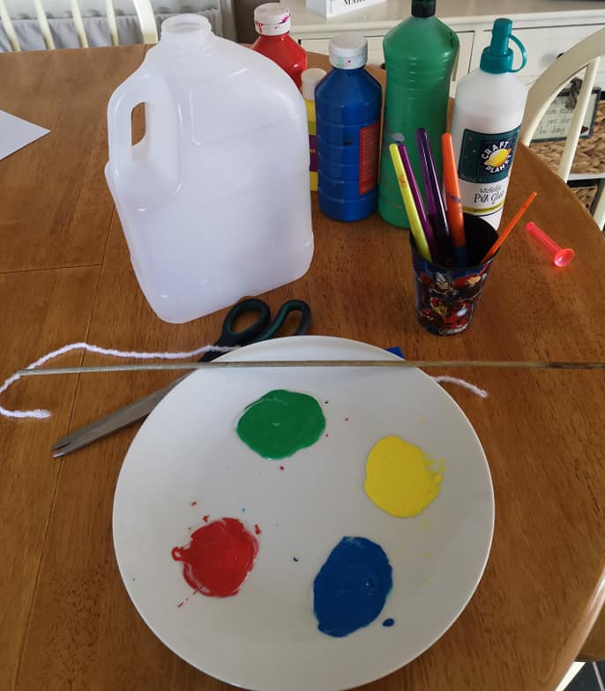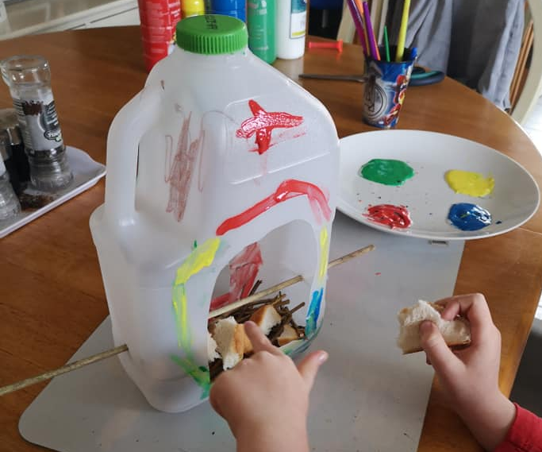

A new table will be given on a weekly basis which includes generalised activities to be completed throughout the week and more individualised activities will be emailed to personal email accounts.
Please feel free to use the helpful list of websites as a suggestion for other activities.

