Home Learning Activities
COLOUR EACH BLOCK WHEN YOU COMPLETE THE LEARNING ACTIVITIY
Theme: Summer Holidays
Technology  Build a sheet fort/ tent for sun bathing in the garden.  (Pics for ideas separate) | Life Skills/ SPHE  Complete 1 outside/ garden job each day. |  |  |  |  |  |  | English/ Oral Language  Choose your favourite place to visit on summer holidays, pretend you are there and write a postcard.  (Template Separate)
 | M |  | T | W | Th | F
Art  Create a chalk pavement art piece. | Social Skills  Play a game of your choice in the garden with your family. |  |  |  |  |  |  | Cookery  Ice Pops  (Recipe attached)
Maths/ Social Skills  Create a shop in the garden. Take turns in being the customer and the shopkeeper. Use real money to buy items. | Physical Education  Take part in 30-minutes of exercise each day. |  |  |  |  |  |  | English  My Personal Journal  Complete 1 entry about your week in your personal journal.
 | M | T |  | W | Th |  | F
Home learning Activities
Here are some activities that will be completed weekly as part of the Middle 1 Home Learning Activities:
My Personal Journal
This unique time will be spoken about in history and I would like Middle 1 to record their time to create something they can treasure for years. This will allow pupils to reflect on their time at home and to share thoughts and feelings. My Personal Journal can include pictures or writing based on your child’s abilities. (More detail in individual email.) 1 or 2 entries per week is plenty and the children will be able to present these when they return to school.
Physical Activity
Physical Activity is very important at this time to help support health and wellbeing. The HSE recommends that all children and young people aged between 2 and 18 years should be active for at least 60 minutes per day. Ideas to help achieve this are:
- The Body Coach Joe Wicks provides a 30-minute workout each day at 9am. This can be watched at any time of the day. www.youtube.com/thebodycoachtv
- Movement and mindfulness videos www.gonoodle.com
- Daily 10 minute exercise videos https://rtejr.rte.ie/10at10/
- Cosmic Kids Yoga (yoga and mindfulness) https://www.youtube.com/user/CosmicKidsYoga

Playing football, racing or daily walks are all great exercise and fun!

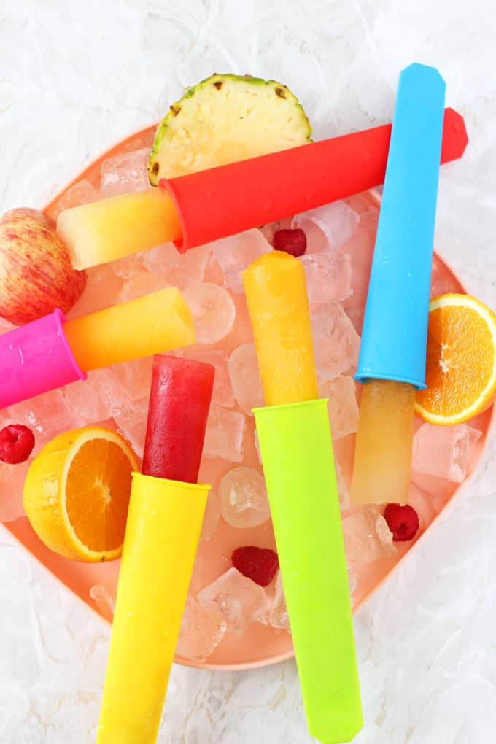
Ice Pop Recipe

Ingredients:
Diluting Juice/ crushed fruit/ lemonade
Water

Instructions:
- Make dilute Juice to the desired taste.
- Pour into Ice pop moulds or plastic/ paper cups (Wrap in cling film).
- Add a ice pop stick/ or spoon.
- Place in freezer.

Build a sheet fort/ tent
